

# Dell Latitude 5290 2-in-1 Tablet

## Type of device: Tablet

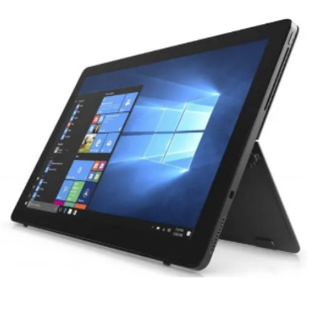

Actual Display Size : 12.3 inches

Operating System : Microsoft

Network Capability : 3G,4G

Year of Release : 2018

Average Price : $1049 as of 24 09 2021

Internet Access : Wi-Fi Only

## Accessibility Features:

### Cognitive

* Additional Instructions
* Copy and Paste
* Flicker Free Display
* GPS
* Photo Telephone List
* Screen Timeout Disabled
* Simple Instructions
* Simple Reminders
* Simplify Display

Voice Notes

### Hearing Impairment and Deaf

* Allows for sign language communication
* Bluetooth or Wi-Fi
* Closed Captioning
* Front Facing Camera
* Video Communications - Two-way

Visual Alerts - Incoming Calls

### Vision

* Accessibility APIs supported
* Battery Alert - Audible
* Bluetooth or Wi-Fi
* Braille Display Support
* Brightness Adjustable
* Dictation / Speech-to-Text
* High Contrast Mode
* Personalised Shortcuts
* Power Cue
* Screen Magnifier
* Screen Reader
* Text Size Adjustable
* Voice Control /Personal Assistant

Voiced Menus

### Speech

* Allows for sign language communication
* Bluetooth or Wi-Fi
* Messaging Options - Email

Predictive Text

### Physical

* Bluetooth or Wi-Fi
* Dictation / Speech-to-Text
* Flat Back for Table Top Operation
* Gesture Based Navigation
* Predictive Text
* Reduced hand movement option
* Speaker-phone option
* Stylus or Prosthetic Device support
* Switch control option
* Visible Focus Indicators
* Voice Control / Personal Assistant
* Voice Recognition for Accessing Features

Voice Recognition for Dialling

## How and where to get it from?

You can buy this tablet from [Kogan](https://www.kogan.com/au/shop/category/tablets/?q=Dell+Latitude+5290+2-in-1&page=1), [Dick Smith](https://www.dicksmith.com.au/da/shop/category/tablets/?q=Dell+Latitude+5290+2-in-1&page=0), and other retailers.

## More information is available on:

[Dell Latitude 5290 2-in-1 Tablet Web Page](https://www.dell.com/en-au/work/shop/laptops/12-2-in-1-5290/spd/latitude-12-5290-2-in-1-laptop)

[Dell Latitude 5290 2-in-1 Tablet User Manual (PDF Download)](https://dl.dell.com/topicspdf/latitude-12-5290-2-in-1-laptop_owners-manual4_en-us.pdf)

[Dell Latitude 5290 2-in-1 Tablet Support Web Page](https://www.dell.com/support/incidents-online/en-au/contactus/product/latitude-12-5290-laptop)